EEE 117 Laboratory

Instructor: Mike Saghaimaroof

**Lab 1: Resistance, Voltage and Current Measurements**

**Lab Report by Luis Rivera**

**Lab Session: Monday**

**Due Date of Lab 2/15/2016**

**Date of the lab: 2/8/2016**

**Introduction:**

This lab is helpful in familiarizing ourselves with the lab equipment and make DC measurements of resistances, voltage and currents in given circuits. We will look at our oscilloscopes, Digital Multimeter and power supply and make readings based on reading the instruments and verifying them with the given knowledge of Kirchhoff Current and Voltage laws.

**Purpose:**

The purpose of this lab is to use our knowledge of the equipment that we have learned over the past two lab sessions and put them to use. We will dive into using the oscilloscope and its two probes; the X1 and X10 probe, checking voltage, resistance and current values using the Digital Multimeter, and building circuits with a specific voltage using the power supply. This lab will also allow us to practice at building circuits as well as learn how to troubleshoot potential problems that occur during the lab and get a sense of how the future labs will go.

**Part 1: Resistance Measurements**

For this part of the lab we needed to measure the resistances of a 100KΩ and 300kΩ resistor to get an actual value using the digital Multimeter and oscilloscope.

|  |  |  |  |  |  |  |
| --- | --- | --- | --- | --- | --- | --- |
| Original Value | DMM Value | Oscilloscope (1X) Resistance | Oscilloscope 10X  Resistance | % Error of Resistor | % Error of Oscilloscope | Oscilloscope off |
| R1 = 100kΩ | 99.625kΩ | 1.002MΩ | 9.9713 MΩ | 1.60% | 0.20% | 0Ω |
| R2 = 300kΩ | 299.26kΩ |  |  | 0.38% | 0.29% | 0Ω |

Picture of the internal resistance of Oscilloscope (1X probe)

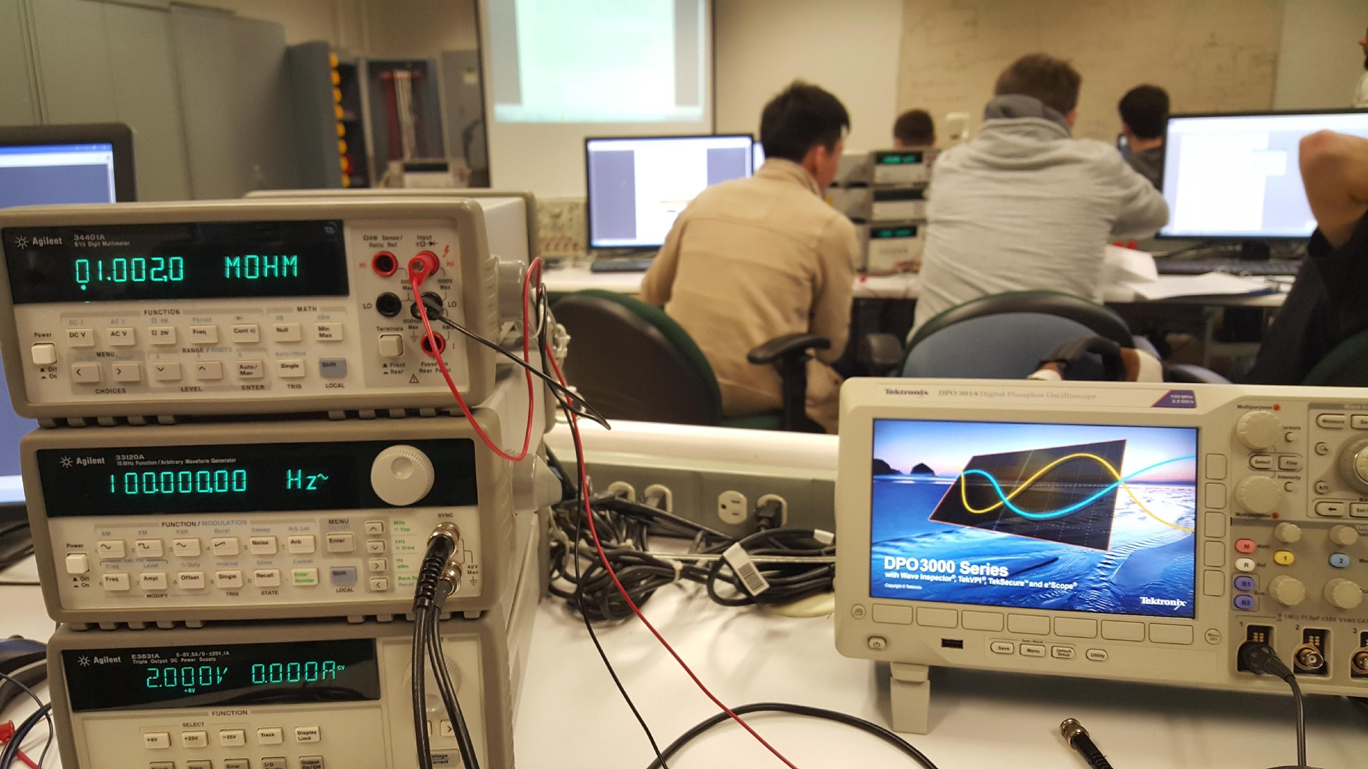

Our calculations showed that the readings of the internal resistance were close to the expected outputs of 1MΩ and 10MΩ as well as our resistor values. There are many factors that can contribute to that like bad equipment with the 1X or 10X cables being damaged, or resistance in the cables.

**Part 2: Voltage Measurements**

**A. Unloaded Voltage Readings**

Here we needed to make circuit like the one pictured below. We used a voltage input of 2V and then used the Digital Multimeter (DMM) to find these values and verified them using Kirchhoff voltage law.

|  |  |  |  |  |
| --- | --- | --- | --- | --- |
| Equipment | DMM Readings | Expected | X1 Probe | X10 Probe |
| 2.0V input | 2.0V | 2.0V | 2.0V | 2.0V |
| 100kΩ | 0.495V | 0.50 | N/A | N/A |
| 300kΩ | 1.486V | 1.5V | N/A | N/A |

To calculate the expected readings, I used Voltage division which was set up by the circuit as the resistors were in series

V0 = 2.0V * (99.625kΩ/(99.625kΩ + 299.26kΩ) = 0.4995V for 100kΩ Resistor

V1 = 2.0V * (299.26kΩ/( 99.625kΩ + 299.26kΩ) = 1.5004V for the 300kΩ Resistor

Kirchhoff Voltage law states that the sum of all voltages must equal to 0.

2.0V – V0 - V1 = 0.

2.0V – 0.4995V – 1.5004V = 0

This confirms that our voltages were correct.

**Part B. Loaded Voltage Readings X1 probe.**

**Part C. Loaded Voltage Reading X10 probe.**

This part required us to use the oscilloscope X1 and X10 probe as build the circuit pictured in the figure below. The key is to set up the probe to be parallel with the 300kΩ resistor. Each probe is done separately

Due to oscilloscope settings, we were unable to measure an adequate reading for the voltage across the resistors, it would give us a line that was too small to calculate. We attempted switching the cables and testing another 1x/10x connector. We also tried to change the scale of the oscilloscope both the horizontal and vertical measurements and the group behind us had the exact same problem. We tried to see if the auto focus would do the trick but unfortunately the results were the same. In the picture at the end of the lab report we have our circuit pictured along with the result of the oscilloscope which did not allow for us to get an accurate reading.

**Part 3: Current Measurements**

For the third and final part of the lab we needed to create a current divider circuit and measure the currents using our known knowledge of Kirchhoff Current Laws (KCL). We needed to change our resistor values for this part as there were not enough 1KΩ resistors so we had a circuit with a 12v supply going into the 3kΩ resistor and then into a 2.0kΩ resistor and 5.0kΩ resistor in parallel. Before finding the currents we measured the exact values for each resistor.

|  |  |  |  |
| --- | --- | --- | --- |
| Resistor | Expected Value | Actual Value | Percent Error |
| 2KΩ | 2000 Ω | 1994.3 Ω | 0.29% |
| 5KΩ | 5000 Ω | 5112.3 Ω | 2.25% |
| 3KΩ | 3000 Ω | 2978.4 Ω | 0.72% |

Once we found the actual resistor values, we could then use the digital multimeter in order to measure the current flowing through each resistor and then compare them to Kirchhoff current law which states that the sum of all currents must equal zero.

Below are our measured and calculated currents.

|  |  |  |
| --- | --- | --- |
| Current | Measured current | Expected Current |
| 2KΩ | 2.3457mA | 3.206mA |
| 5KΩ | 1.8328mA | -0.487mA |
| 3KΩ | 2.719mA | 2.719mA |

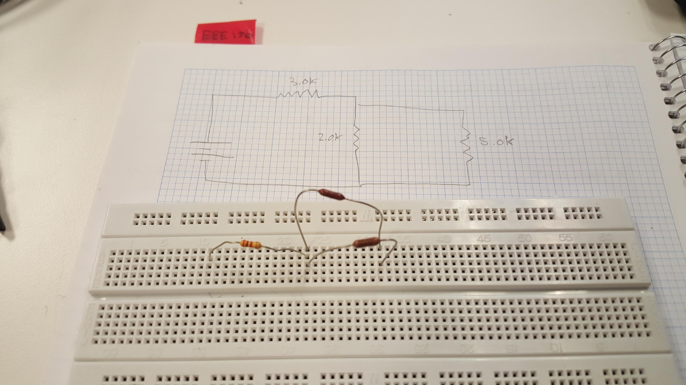

Pictured above is our circuit along with the diagram showing where our resistor values are and pictured below is the circuit we needed to make.

In order to measure the currents we will use our knowledge that Ohm's law involves V = I*R (Current x Resistance) which we can then use our knowledge of currents in series and parallel to find the expected currents.

12V – (2978.4 Ω*I) – (2.0k*I2 || 5.0k*I3) = 0

We can then use our loop rule around the first loop in order to find the current for the 3K resistor which calculates to finding the parallel value between the 2KΩ and 5kΩ resistor which calculates to

R4 = 1434.65Ω

Loop 1: 12V – (2978.4 Ω * I1) – (1434.65 * I2) = 0

The 4413.05Ω and 1434.65Ω resistors are in series which comes out to being 4413.05Ω which means we can simplify the circuit to solve for a single total current.

12V – (4413.05Ω * I) = 0 which means the total current is 2.719mA

Multiplying that value using Ohm's Law by the current by the 3k Resistor

V = I*R → (2.719mA * 2978.4 Ω) = 8.098V

Using this value we know that the first resistor absorbs 8.098V from the total 12V of the circuit which can simplify the circuit

12V – 8.098V - ( 1434.65 Ω * I2) = 0

Solving for I2 gives us 3.902V - ( 1434.65 Ω * I2) = 0

3.902V = 1434.65 Ω * I2

3.902V/1434.65 Ω = I2

I2 = 2.7196 mA

We also know that I2 = I3 + I4 leaving us with the second loop

Loop 2: 1994.3 *I3 - 5112.3 * I4 = -3.902V

I3 = 2.7196 – I4

-5.4225V + 1994.3I3 -5112.3I3 = -3.902V

-3118I3 = 1.5205V

I3 = -0.487mA

We also know that I2 = I3 + I4

2.7196mA = I4 + 0.487mA

I3 = 3.206mA

Finally we can use the known currents to plug then in to ensure KVL is also correct.

12V - ( 2.719mA * 2978.4 Ω) – (3.206mA*1994.3 Ω) - ( -0.487mA *5112.3 Ω) = 0

12V – 8.098V – 6.3937V + 2.493V = 0

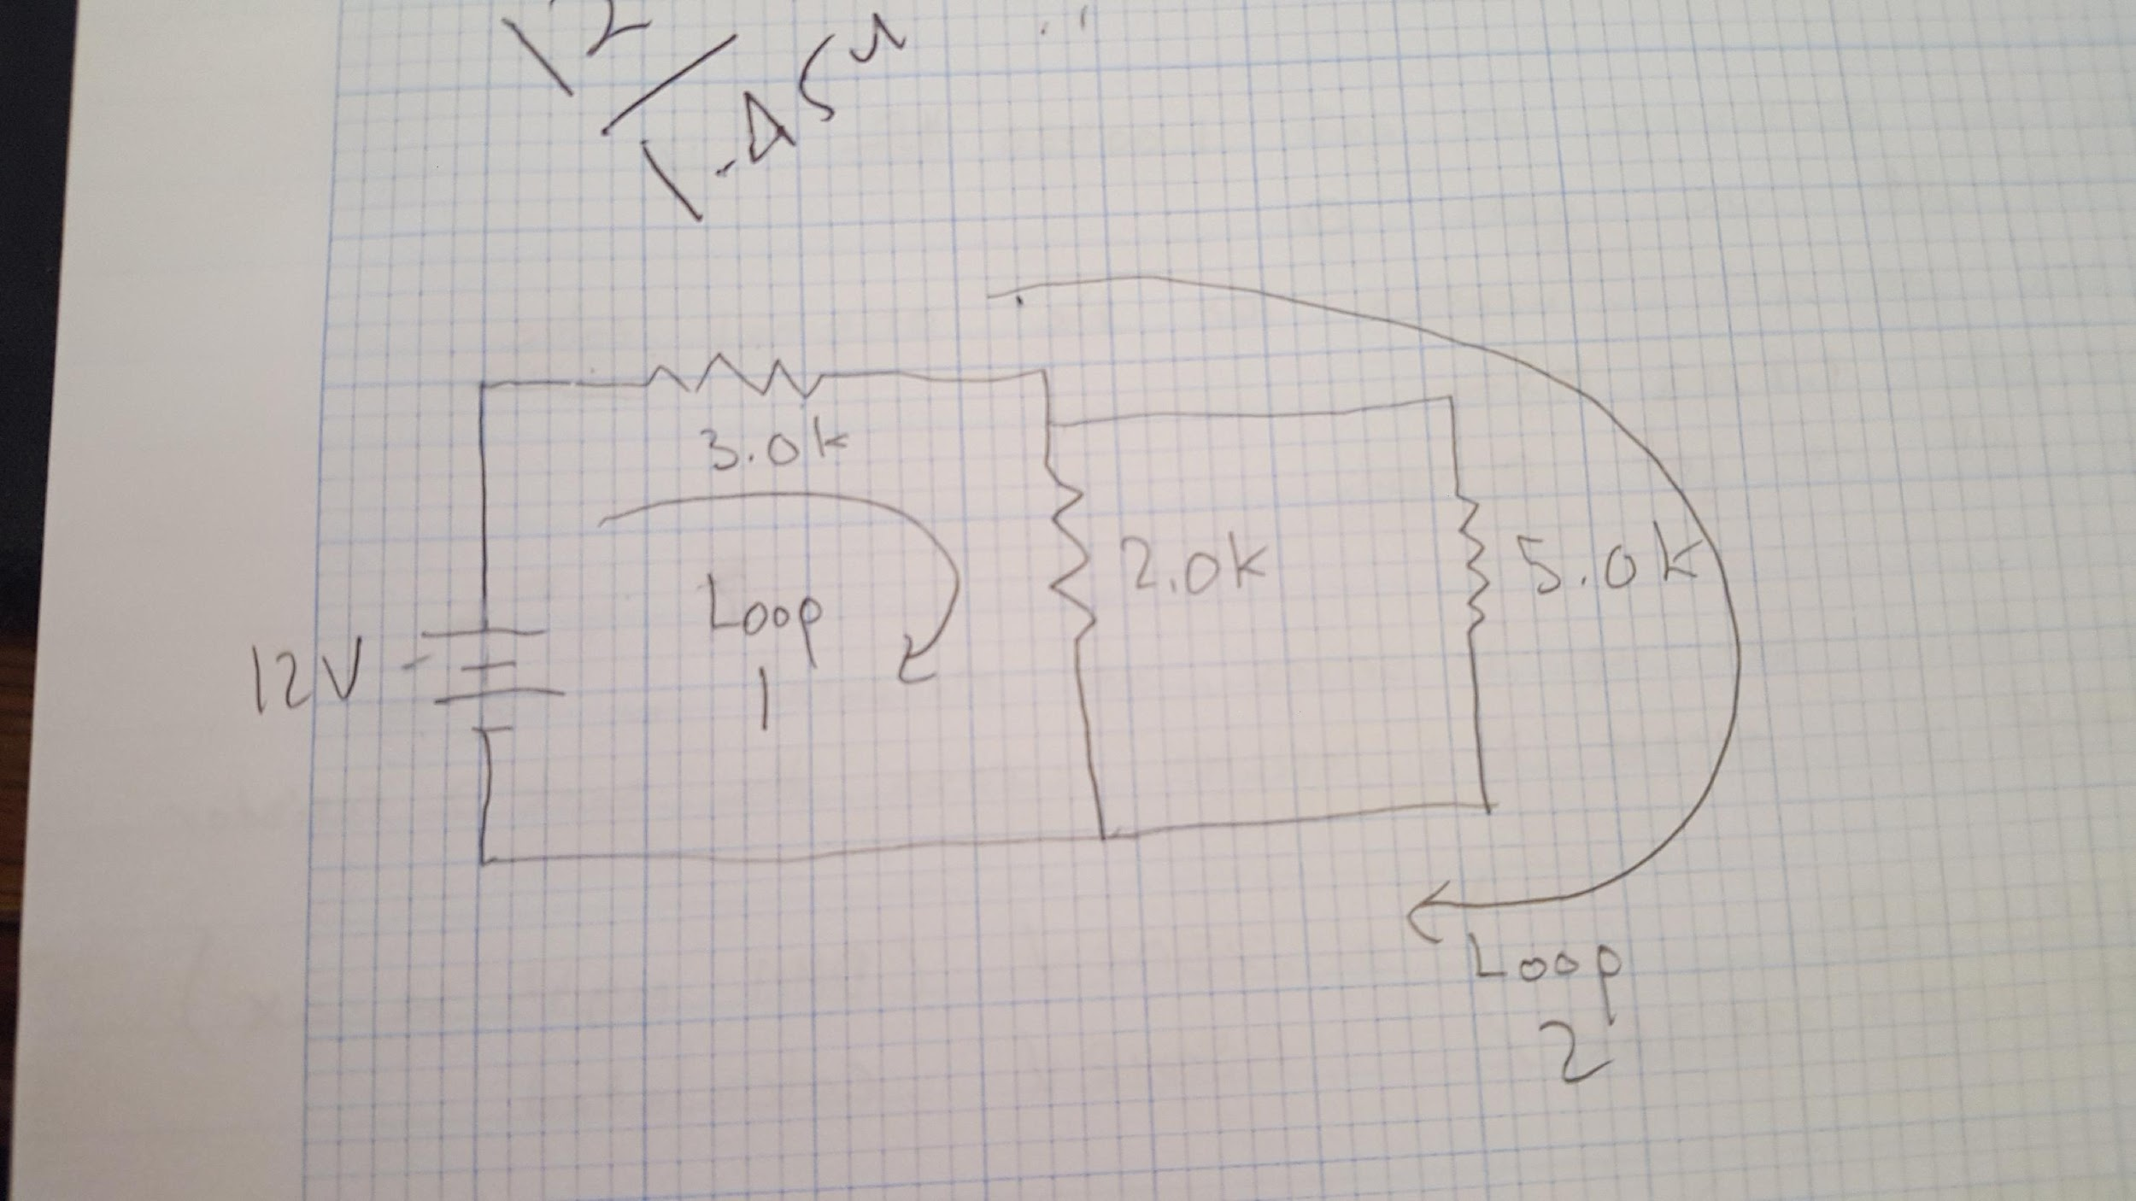

**Result analysis:**

After doing calculations it is clear that we messed up in taking the correct current of the wires, our measured results were off what was calculated. I had allowed my partners to do the calculations as opposed to me and I did not look and make sure they were doing the wiring correctly. I also should have done the wiring to make sure I understand how to take the correct current for this experiment. The values were incorrect with the given circuit and instead were correct if the circuit were in series but it was due to not breaking the wire connection correctly.

**Discussion Topics:**

1. I verified the Kirchhoff laws in calculations and only in the voltage calculations were they correct, we did not get correct current values as it seems our current calculations were only correct if the circuit was completely in series which falls under what our lab instructor stated that we need to cancel out the wire when taking currents or we would end up with incorrect readings. Judging by the information given and data given
2. Yes, we used current and voltage divisions to verify our results which resulted in our voltage division being correct but not our current division.
3. Oscilloscope probes showed promise and expected results when we tested internal resistance but not when we tried to find the voltage in our circuit for part 2.
4. We were unable to get an accurate number but from the looks of the graph we expected that the value was close to what was expected.
5. Very close, each of our values were within 2% of the given value which in turn helped us get accurate values for our circuit.
6. We would rather use the X1 probe if we wanted to disturb the circuit as little as possible due to the lower internal resistance.

**Conclusion:**

Overall, this lab went a bit poorly for us in terms of getting adequate results, we had problems with our oscilloscope reading our voltage correctly and were unable to fix the problem through various means of troubleshooting. We also seem to have an error in terms of taking the correct current of the circuit which hurt our experimental values and caused mass confusion. In the future, I'm going to double and maybe triple check each value to ensure we are getting completely accurate and reasonable data.

Below is our picture of our oscilloscope which provided a vague representation of our voltage data along with a glimpse of our breadboard wired.

